Introduction

Inside Ferromagnets, their spin magnetic moments algin themselves in the same direction [Ferromagnets]. This is due to the strong interaction between the magnetic moments, creating a lower energy state for aligned ordering than random. Ferromagnetism is only exhibited in low temperatures, up to the curie temperature, $T_{c}$ [curie temp]. For temperatures above $T_{c}$, ferromagnets loss their aligned ordering as the spin magnetic moments rotates in random directions, transitioning into a paramagnetic state

Inducing paramagnetic properties instead.

<<pic of spin states>>

**Ferromagnetism**

**Paramagnetism**

Ising model

To simulate the arrangement of spins in a ferromagnet, and how they change due to temperature, one can use the Ising model [ising model]. The system is comprised of $N$ number of sites in a square grid, each one either in the up or down spin state, $s=±1$. The energy of a site depends on its own spin and the spin of its nearest neighbours, it can be calculated with

$$\frac{E_{i}}{J}=-\sum_{k}{s_{k}s_{i}}$$

where $E_{i}$ is the energy of the spin, $s_{i}$ is the spin state of the chosen site, $J$ are the spin states of the site’s nearest neighbours, and $J$ represents the strength of the interaction forces between the sites [energy of state]. The adjacent spins create a local magnetic field which influences the direction a spin will align, a spin aligned parallel with its neighbours will have a lower energy than if it were antiparallel. The total energy of the system, $E$, is just the sum of equation () over all $N$ sites, while the system’s magnetisation, $M$,can be calculated with

$$M = \frac{1}{N}\sum_{i}{s_{i}}$$

When the system is subjected to heat, the energy it receives can allow a site to switch spin state, even raising it to a higher energy level. This can be determined by the Boltzmann distribution

$$p_{i}=exp(\frac{-∆E_{i}}{k_{B}T})$$

where $p_{i}$ is the probability of a site switching its spin state, $k_{B}$ is the Boltzmann constant, $T$ is the temperature of the system, and $∆E_{i}$ is the difference between the energy of the site’s initial spin state to the other spin state[boltz]. If $∆E_{i}$ is negative, it will much more likely switch than if it were positive, showing the preference for the state with a lower energy. However, the probability to change to a higher energy state is not zero, with it increasing as temperature increases.

The arrangement of all the spin states in the system will create a microstate, when a site switches spin state, it changes to a different microstate. Over a long period of time, where most of the sites have had the chance to change their spin state, the system reaches thermal equilibrium [therm equri]. This is where the rate at which the system switches from one microstate to another, equals the rate at which the system switches back to the original microstate. Meaning the system’s total energy and magnetisation converge to a constant value.

Code

To implement the Ising model computationally, a C++ script was created. A 40x40 square grid was created, as shown in fig (). Each point had a cartesian coordinate, relative to the first site, and either an up (blue) or down (green) spin state. The system had an inverse temperature variable, $β$*,* which could be called up or changed with a function. It had dimensionless units and was calculated by

$$β=\frac{1}{T_{0}}=\frac{J}{k_{B}T}$$

where $T_{0}$ is the dimensionless temperature, and $T$ is the temperature in kelvin. Metropolis Monte Carlo was used to simulate whether a site switches spin states due to heat energy in the system [carlo]. A site is picked using a random number generator, then $∆E_{i}$ was calculated for it. If $∆E_{i}>0$, a random fraction was generated and compared to $p_{i}$ of the site. If the fraction was less than or equal to $p_{i}$, the site switched spin states, while if the fraction was larger, the sites did not switch. If $∆E_{i}<0$, it was assumed $p_{i} = 1$ and the site always switched spin state. This was repeated over many iterations to bring the system into thermal equilibrium.

Once equilibrium was reached, the $E/J$ and $M$ can be calculated, with equations () and () respectively, for the whole grid. To calculate the nearest neighbour spins for the sites at the edge of the grid, the corresponding site on the other side of the grid were used, acting as if the grid had periodic boundaries.

Fig() An iteration of the simulated Ising model during thermal equilibrium, at $β=0.25$.

Convergence to Equilibrium

To show that the system converges to a thermal equilibrium, its $M$ and dimensionless energy per spin site, $E/JN$, were calculated using equations () and (), at each iteration up to 500. This process was repeated 50 times, then the average of $M$ and $E/JN$ at each iteration were calculated, as to give an expected value at each iteration. This was repeated for different $β$ and plotted on the same graph, in figures (num – num).

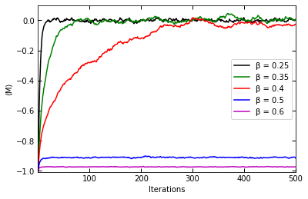

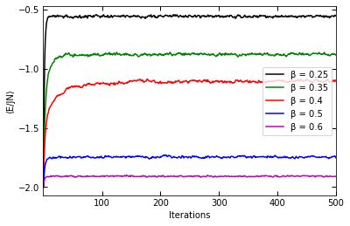

Fig(): Average $M$ (top) and Average $E/JN$ (bottom) against iterations of the Ising model simulation. Each line represents the different $β$ the simulation was running at: 0.25 (black), 0.35 (green), 0.4 (red), 0.5 (blue), and 0.6 (purple).

$⟨M⟩$ for all the temperatures converge to a constant value, as seen in fig (a). For high beta, therefore low system temperature, $⟨M⟩$ stays close to its oringla value, converging close to -1. This shows the ferromagnetism state continues during thermal equilibrium, as the spin states stay mostly aligned in the same direction. For low beta systems, $⟨M⟩$ converges to 0, as they fluctuate around the value. This shows the systems transition to a paramagnetic state at thermal equilibrium, as a this indicates there is not a favoured spin direction, it is equally likely to be in the up or down spin state. So, the neighbouring spin states of a given site have no effect on the site’s spin.

In terms of speed of convergence, both very high and low beta systems reach equilibrium quickly, within the first 100 iterations. However, systems with their temperature near tc will take much longer, the system with beta = 0.4 in fig () took more than 10 times as many iterations to reach a constant value than the other systems tested. This suggests that as a system approaches its tc, and transitions from one state to the other, the speed at which thermal equilibrium is reached increases.

$⟨E/JN⟩$ also converged to a constant value for all system temperatures. However, unlike $⟨M⟩$, the converging value is depenatnt on the system’s temperature. As beta increases, so the temperature decreases, $⟨E/JN⟩$ gets more negative.

This indicates that the systems that are in a paramagnetic state, are at a higher energy microstate than the systems exhibiting ferromagnetism. This higher energy allows for the sites to misalign their spin compared to their neighbours. This is consistent with equation (), the higher energy result in a higher spin state switching probably.

Equilibrium values

Once the systems reach thermal Equilibrium, their properties can be measured to see more clearly how temperature affects it. After 1000 iterations, the average $E/JN$, $M$, and the modulus of $M$ were calculated for the whole system over 50 iterations. This was repeated for different t0 and plotted on the same graph, in figures (num – num).

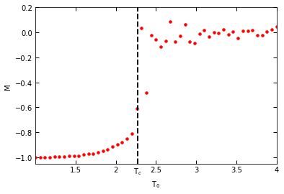

Fig():Average $M$ (top), average $\left|M\right|$ (middle) and Average $E/JN$ (bottom) against the system’s temperature. The vertical black dotted line indicates Tc on each graph.

In fig()

Mag

When the system is at low temperatures, M remains at a constant of value -1, showing the system is still in the ferromagnetic state. As T0 increases, M slowly increases as more spin sites switch state due to an increase in P. This changes when T0 = 2.27, as M dramatically increases to a value of 0. After this, the system fluctuates about m=0 with increasing t0. This indicates the system undergoing a phase transition to the paramagnetic state, with $T_{c}≈2.27J{k_{B}}^{-1}$.

This is

until it dramatically increases to M = 0,

It start to slowly increase in M, until it dramatically increases to m 0. This indicates the phase transition change to the paramagnetic state. After this, M fluctuates about 0 M, which is to be expected by a paramagnetic system.

The tempuarture where this phase transition occurs is at 2.27T0

The slight increase in M just before the Phase change.

For the tempurates near the tc that don’measure at 0 or 1 because theu propaly didin’t have enough time to converge. As seen in fig (converge time), when the temp approaches tc, it takes more iterations to converge to a point.

Absoulet mag

The modulus of m depicts the same thing as M, a ferromagnetic system with it’s spins allgined transition into a paramagnetic state at the temperature Tc. However, at these high temperatures, Mod M stays at a consistent valve, suggesting that the paramagnetic state the system is in is not as chaotic

Energy,

As seen in figure (converge), the system didn’t stay at a constant energy for either magnetic state, like for M, it always increased with temperature.

energy per spin site increases gradually for low temperatures. This rate of change increases as the temperature approaches TC.

However, as temp approaches Tc, the rate of energy change increases. Until it reaches a maximum gradient at TC. This suggests that the closer to tc the system is, the more the temperature affects the energy increase.

Sensitive and susceptible the system is to energy increase = infinite

This is due to a upper threshold of the energy state

The system’s sites can only be in two states, therefore for the grid simulated, there is a finite upper limit to the maximum energy the system can occupy. So

The more sites that switch spin states, the greater the energy change between the two spin states. Therefore the prob to switch between the two states increases. So the temperature has to increase by a greater amount to keep the same gradient

Exact solution

The exact solution for the magnetisation of a 2D Ising model was found as

$$\left|M\right|={\left[1-\frac{1}{{(\sinh{(\frac{T_{c} }{T}ln(1+\sqrt{2})}))}^{4}}\right]}^{\frac{1}{8}}$$

[Lars Onsager]. However, this is only valid for temperatures below TC and assumes the grid lattice is very large. The exact modulus of mag was compared with the ones simulated. 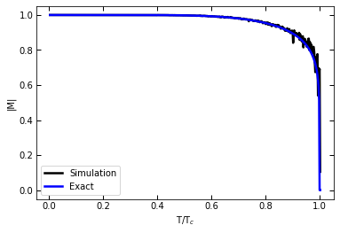

Fig

The simulation and exact follow near similar shapes.

For low temperature, the exact follows the simulated with little divetation. However, as the ratio between Temperatureand TC approaches 1, the more the simulation starts to fluctuate. The ecat mag also decends and quicker rate than the sim

The main difffernec is that the sim has a grid lattice size of only 1600 sites, while the exact was solved for lattices magnitudes larger than that. So if the simulation increased it’s lattice size, the more it will form the shape of the exact

Mean Field Theory

An approxitmaet soultuion to magnetissim is the mean field theory

It assumes at every spin site act similar to the rest of the sites in the grid lattice. The local magnetic field each site has is

Each site can be taken out of the lattice and put in a

It doesn’t take into affect the neigbouring sites. Each site is effectively isolated

It doesn’t work so well of temperatures near TC, but it works well for low temperatures, as the local magnetic field is the same for the majority of the sites, as most of the sites have their spins aligned in the same direction.

Grid Lattice

Effective Isolated Medium

Compare mean field with ising

M was calualted for varrois temperatures from 0 to TC. It was ploted with the Isisng

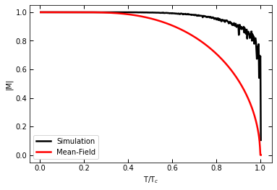

For low temperature, up to a ratio temperature to tc up to 0.4, the mean field M follows the sim closely, keeping the a Mod M of 1. However, the Mean field’s M begins o drop at a much lower temp than the sim,

steadly decreasing to 0

this is due to the isolated spin sites. The average maginetic medium steady increases the probability to switch states. However, in the sim, it choses a site randomly. And each site colud have any varrion of local magntic field. So the mod mag stays at one longer

2.

For the mag vs temp grapgh, it shows a critical temp where it is para magnetic (mag = -1) then turns intoa random matrial (high temp makes the spins rotate randomly )

The energy is an s shape, with the mindile point being the same critical temperature

how 3 differens from 2 is that at low t, it stays at m=1, then as it goes to critical temp, it steady dives to m=0 (where the spins are random)

In 2, it is a more sharp decent

3.

The sim works great up intill it reached temp c

The exact solution gives the same shape as the sim, however due to the exact assuming ght egrid is very large/infinte. It is smooth, rather than the sim fluctureates about as the sim is only 40x40

Mf is the same at low temp, but starts to drop at a low gradient near t/tc = 0.4 rather than the deep, suden drop like in the ising model.

Linking

4. the sim for the c and chi are good at low temps

Chi is at zero when the grad of (e vs t) will be flat, so it works

Both have similar shapes, c gently rises while chi steeply rises

However, when t approaches tc, it becomes more frantic

Ref

Curie temp